# Informações do estudo

Referência: Keblouti - uncoated insert

Grandeza: Força

Tipo: Fx

Material: AISI 52100

Ferramenta: CT5015 uncoated insert

Número de experimentos: 27

Observações:  
Universal lathe SN 40C type  
Workpiece: round bars66 mm of diameter and 380 mm cutting length.  
Dynamometer: KISTLER Type 9257A  
Roughnessmeter: Surftest 201 Mitutoyo

# Unidades

Velocidade: m/min

Avanço: mm/rev

Profundidade de corte: mm

Força: N

# Dados de teste

|  |  |  |  |
| --- | --- | --- | --- |
| Força | n | f | a |
| 37.12 | 200.0 | 0.08 | 0.15 |
| 113.01 | 150.0 | 0.08 | 0.45 |
| 76.1 | 200.0 | 0.16 | 0.3 |
| 84.21 | 250.0 | 0.16 | 0.3 |
| 41.06 | 200.0 | 0.16 | 0.15 |
| 65.15 | 200.0 | 0.12 | 0.3 |

# Dados de treino

|  |  |  |  |
| --- | --- | --- | --- |
| Força | n | f | a |
| 111.5 | 250.0 | 0.16 | 0.45 |
| 70.28 | 200.0 | 0.08 | 0.3 |
| 95.51 | 250.0 | 0.08 | 0.45 |
| 108.06 | 250.0 | 0.12 | 0.45 |
| 81.32 | 150.0 | 0.16 | 0.3 |
| 26.74 | 150.0 | 0.08 | 0.15 |
| 57.64 | 250.0 | 0.12 | 0.3 |
| 146.82 | 150.0 | 0.16 | 0.45 |
| 129.13 | 150.0 | 0.12 | 0.45 |
| 46.66 | 200.0 | 0.12 | 0.15 |
| 43.52 | 150.0 | 0.16 | 0.15 |
| 39.22 | 250.0 | 0.16 | 0.15 |
| 94.91 | 200.0 | 0.12 | 0.45 |
| 54.41 | 250.0 | 0.08 | 0.3 |
| 46.6 | 150.0 | 0.12 | 0.15 |
| 111.24 | 200.0 | 0.08 | 0.45 |
| 37.59 | 250.0 | 0.08 | 0.15 |
| 25.47 | 250.0 | 0.12 | 0.15 |
| 108.12 | 200.0 | 0.16 | 0.45 |
| 76.57 | 150.0 | 0.12 | 0.3 |
| 69.49 | 150.0 | 0.08 | 0.3 |

# RN

Número de neurônios: 29

Taxa de aprendizado: 1.000000e-03

Número de épocas: 469

2° camada: False

Função de ativação: relu

# Erros

**Dados de teste**

* Erro relativo médio: 6.44
* Coeficiente de correlação: 0.98
* Coeficiente de determinação: 0.95
* MSE: 45.25
* RMSE: 6.73

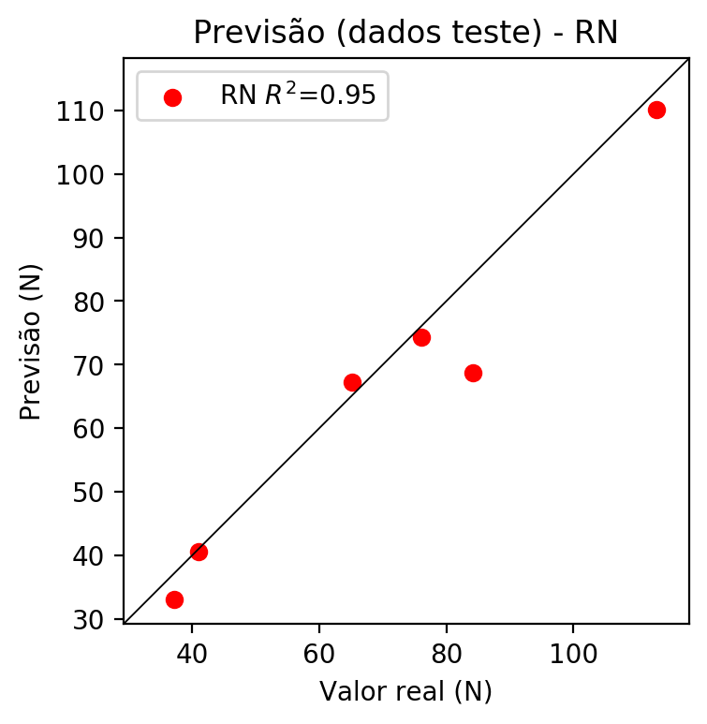

**Dados de treino**

* Erro relativo médio: 8.95
* Coeficiente de correlação: 0.98
* Coeficiente de determinação: 0.96
* MSE: 51.03
* RMSE: 7.14

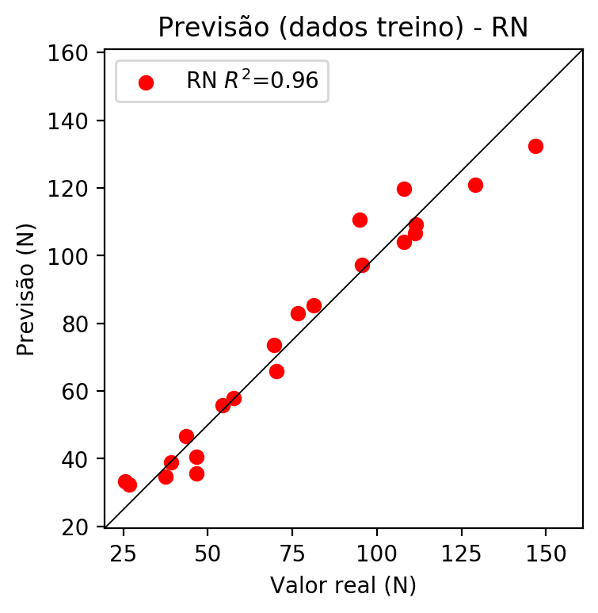

# Pesos

Pesos - camada oculta 1

[[ 0.12655884 0.02177193 -0.15765661 0.25901726 0.10361046 -0.09569952  
 -0.31114194 0.29867008 0.14436947 -0.16875434 -0.23028103 0.1357487  
 0.03575186 -0.29583827 -0.0587124 0.03123165 -0.20821543 0.09601384  
 -0.21843472 0.12027838 0.20506369 0.15751536 -0.07557455 0.08577058  
 0.17099084 -0.1932831 0.25410062 -0.19325978 0.1737278 ]  
 [-0.22639921 -0.00589204 -0.46872392 -0.37181568 -0.36719206 -0.09664646  
 -0.23718569 -0.01866609 0.18634464 -0.1105193 -0.21539514 0.02367491  
 0.06432444 0.4720007 0.20137411 0.2185194 -0.02005318 0.06342679  
 -0.1504524 0.20029017 0.540715 0.04774471 0.20684609 0.1138794  
 -0.41017574 -0.22099215 -0.01153043 0.0680066 0.04212749]  
 [-0.3007646 -0.3110997 0.2290701 -0.4178633 -0.25562885 -0.00467875  
 0.592766 -0.49277985 -0.22593686 0.38397786 -0.49799082 -0.13367054  
 -0.01657656 -0.08763736 -0.12068198 -0.44024414 0.39100155 -0.42313102  
 0.00327113 0.5190187 0.16785842 -0.014757 0.24445234 -0.3273123  
 -0.5654358 -0.12367494 -0.14146565 0.5555103 0.08415049]]

Bias - camada oculta

[-0.1215466 -0.0689334 -0.09371094 0.09057586 -0.08956165 -0.10939857  
 0.05306652 0.15565455 0.22204073 0.05874211 0.14182384 -0.12403788  
 -0.10248735 0.10615294 -0.1676217 0.22576778 0.19485249 0.22253875  
 -0.15593119 0.07871309 -0.2017342 -0.13996479 -0.06592776 -0.10396119  
 0.18654506 -0.12776433 -0.14927778 0.18750755 -0.15181598]

Pesos - camada saída

[[ 0.17379384 -0.00237181 -0.16749845 -0.12484391 0.13471454 -0.14412692  
 0.18233177 -0.14103213 -0.40440184 0.45162892 -0.18123546 0.17346056  
 0.05810348 0.24606657 -0.10611197 -0.35258073 0.38797975 -0.31162155  
 -0.2513711 0.42221934 0.2348159 0.19059932 0.04671498 0.1231191  
 -0.2513036 -0.20292342 0.30504453 0.3355151 0.22249496]]

# Iterações

|  |  |  |  |  |  |  |
| --- | --- | --- | --- | --- | --- | --- |
| Média | Desvio | n | ln | 2° camada | Função | Épocas |
| -0.2934 | 0.272 | 10 | 0.1 | False | relu | 38 |
| -0.4939 | 0.3117 | 17 | 0.1 | True | relu | 716 |
| -0.2892 | 0.2269 | 7 | 0.01 | True | tanh | 130 |
| -0.2486 | 0.2592 | 19 | 0.001 | False | tanh | 282 |
| -0.1817 | 0.1843 | 29 | 0.001 | False | relu | 469 |
| -0.4561 | 0.3279 | 88 | 0.1 | False | tanh | 926 |
| -0.2851 | 0.2399 | 95 | 0.0001 | True | relu | 984 |
| -0.3842 | 0.1117 | 10 | 0.01 | True | tanh | 865 |
| -0.7056 | 0.5219 | 58 | 0.001 | True | relu | 8 |
| -0.3184 | 0.2829 | 9 | 0.01 | False | tanh | 514 |
| -0.2732 | 0.24 | 73 | 0.0001 | True | relu | 729 |
| -0.2965 | 0.2968 | 22 | 0.001 | True | relu | 543 |
| -0.2834 | 0.195 | 25 | 0.1 | True | relu | 562 |
| -0.2377 | 0.2469 | 53 | 0.001 | False | relu | 498 |
| -0.333 | 0.2731 | 83 | 0.01 | True | relu | 337 |
| -0.2531 | 0.2257 | 99 | 0.01 | False | tanh | 16 |
| -0.3035 | 0.2721 | 23 | 0.01 | False | relu | 472 |
| -0.4008 | 0.3129 | 24 | 0.001 | True | relu | 778 |
| -0.2675 | 0.2019 | 58 | 0.01 | True | tanh | 382 |
| -0.6989 | 0.4136 | 35 | 0.1 | False | tanh | 596 |

# RL

# Coeficientes

[ 0. -0.17991923 0.16707358 0.9435098 ]

# Erros

**Dados de teste**

* Erro relativo médio: 9.63
* Coeficiente de correlação: 0.97
* Coeficiente de determinação: 0.94
* MSE: 46.2
* RMSE: 6.8

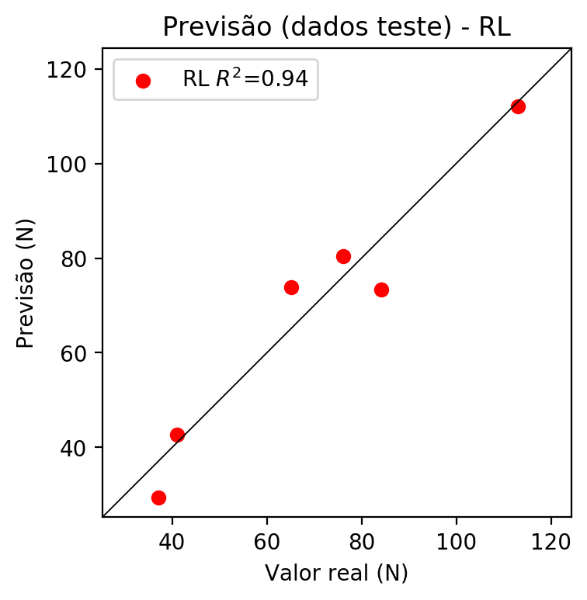

**Dados de treino**

* Erro relativo médio: 12.24
* Coeficiente de correlação: 0.96
* Coeficiente de determinação: 0.93
* MSE: 82.45
* RMSE: 9.08

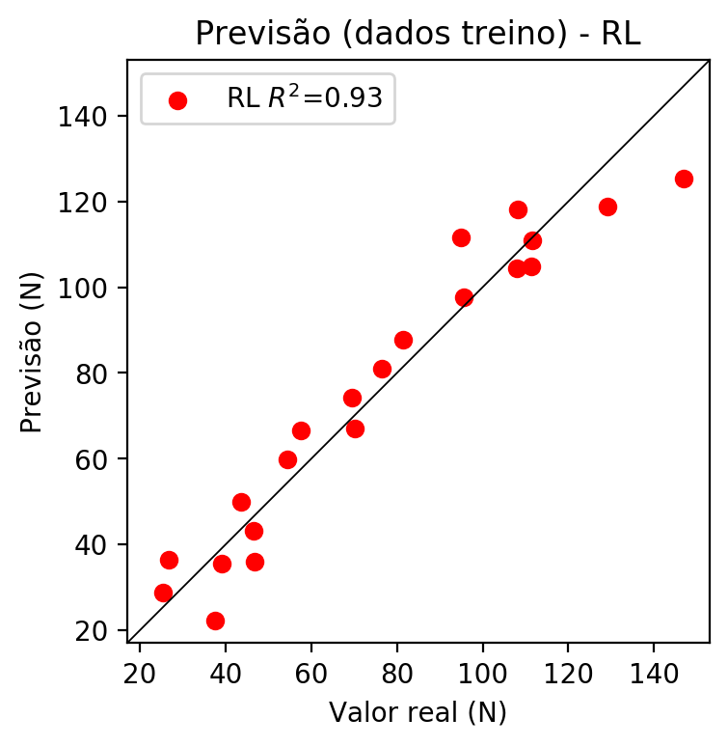

# RP2

# Coeficientes

[ 0. -0.20703766 0.11774415 0.95756264 0.06819939 -0.04766364  
 -0.11752539 0.02697144 0.02152063 0.17123586]

# Erros

**Dados de teste**

* Erro relativo médio: 9.76
* Coeficiente de correlação: 0.95
* Coeficiente de determinação: 0.91
* MSE: 95.6
* RMSE: 9.78

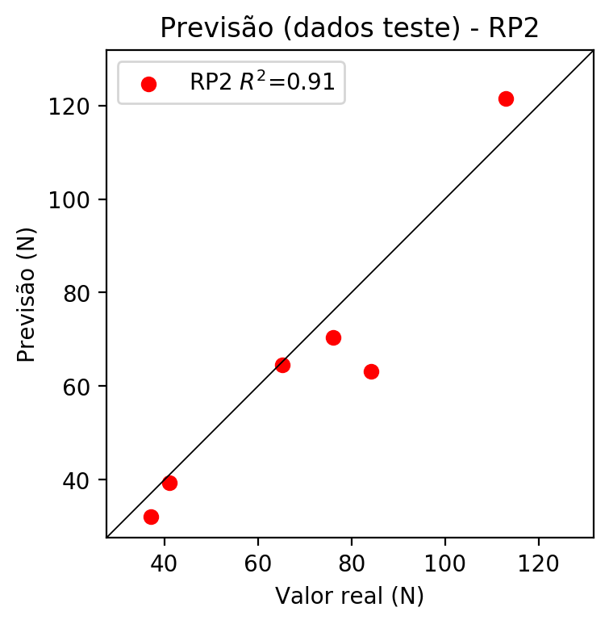

**Dados de treino**

* Erro relativo médio: 10.15
* Coeficiente de correlação: 0.98
* Coeficiente de determinação: 0.96
* MSE: 51.16
* RMSE: 7.15

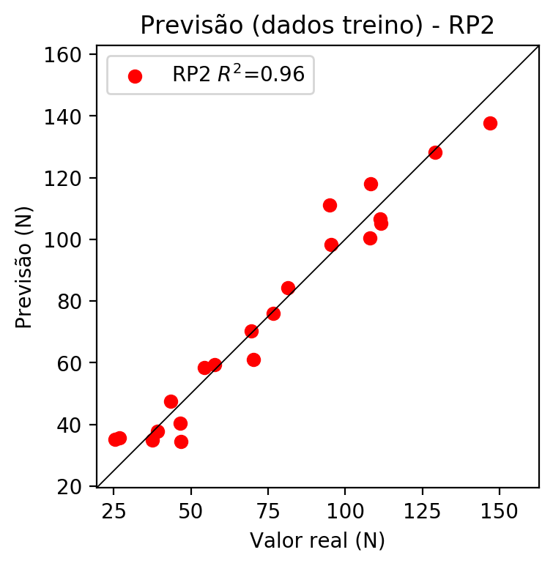

# RP3

# Coeficientes

[ 0. -0.08753356 -0.05184276 0.22550815 0.05086569 -0.05219657  
 -0.11520074 0.03581538 0.0604427 0.22624977 -0.12643736 0.19874088  
 0.20028829 0.04955379 0.00971179 0.01609866 -0.07488399 0.0411259  
 0.04197007 0.325734 ]

# Erros

**Dados de teste**

* Erro relativo médio: 17.69
* Coeficiente de correlação: 0.87
* Coeficiente de determinação: 0.76
* MSE: 183.71
* RMSE: 13.55

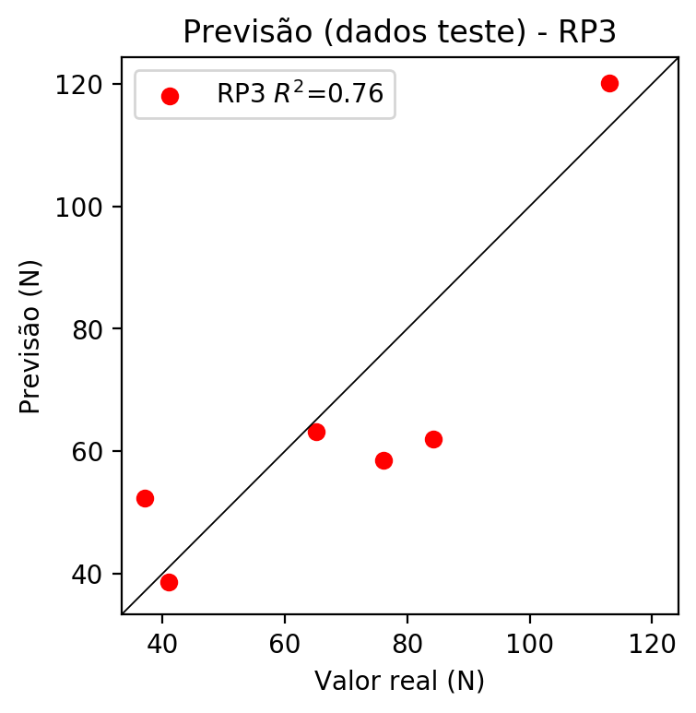

**Dados de treino**

* Erro relativo médio: 5.89
* Coeficiente de correlação: 0.99
* Coeficiente de determinação: 0.99
* MSE: 15.03
* RMSE: 3.88

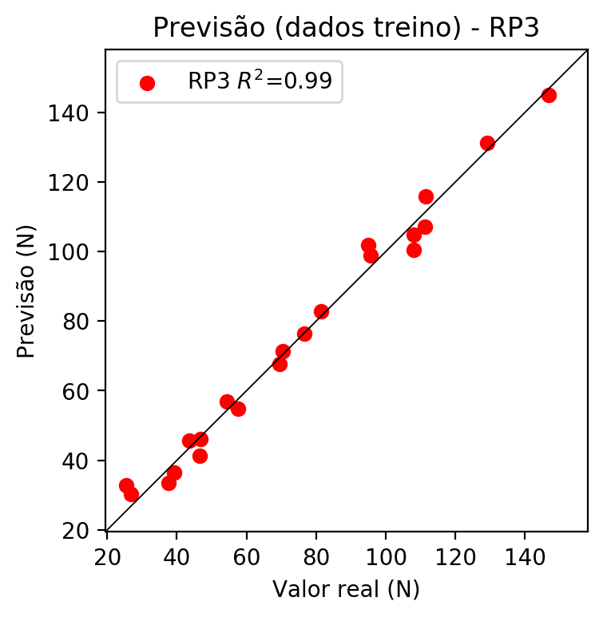

# RP4

# Coeficientes

[-4.16333634e-17 -7.66528194e-02 1.17885006e-02 1.95377630e-01  
 1.36543492e-02 -6.80209307e-03 6.03079184e-05 4.48574097e-02  
 -1.11997039e-02 3.84516787e-02 -1.10720739e-01 4.78909933e-02  
 2.96860479e-01 4.03472783e-03 7.26679288e-02 -1.87754952e-02  
 1.70278342e-02 5.57959400e-02 -3.98005889e-03 2.82212132e-01  
 1.97229489e-02 -9.82524554e-03 8.71114376e-05 -1.09266090e-01  
 3.13348694e-02 6.48449439e-02 -9.82524554e-03 -1.72338168e-01  
 3.02894399e-02 8.71114376e-05 6.47940363e-02 -1.61773501e-02  
 7.03887075e-02 -1.61773501e-02 5.55413137e-02]

# Erros

**Dados de teste**

* Erro relativo médio: 24.4
* Coeficiente de correlação: 0.82
* Coeficiente de determinação: 0.68
* MSE: 408.11
* RMSE: 20.2

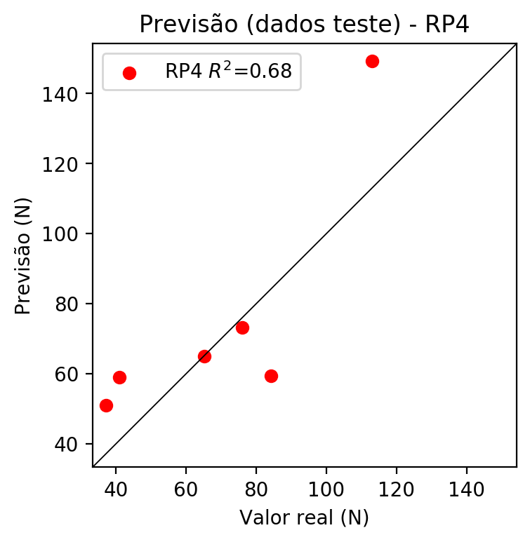

**Dados de treino**

* Erro relativo médio: 0.0
* Coeficiente de correlação: 1.0
* Coeficiente de determinação: 1.0
* MSE: 0.0
* RMSE: 0.0

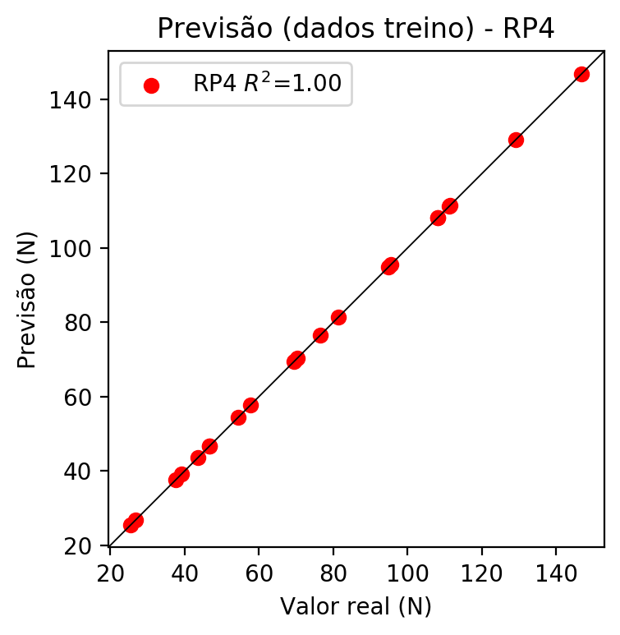

# Geral

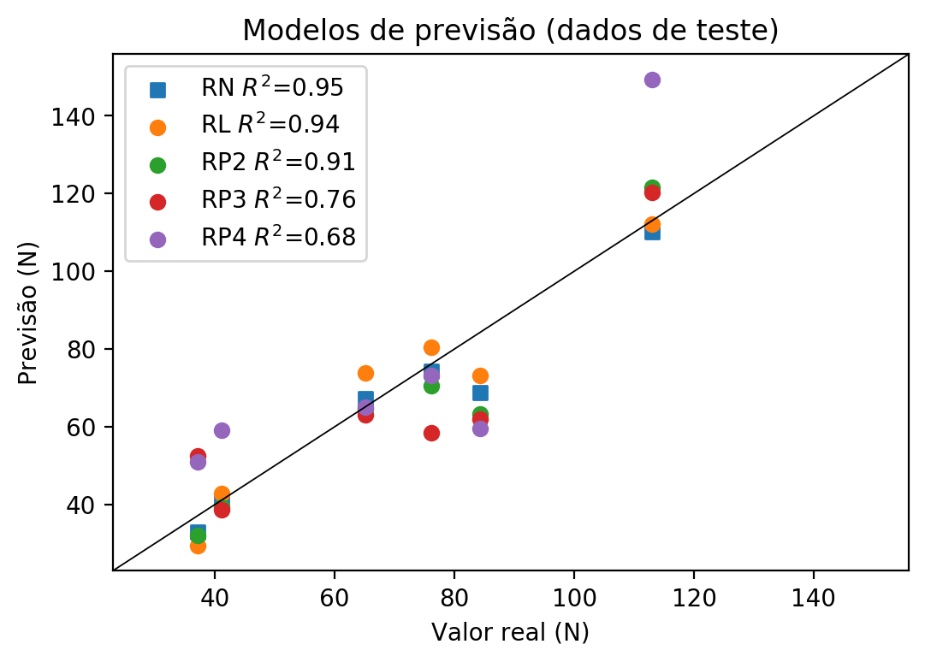

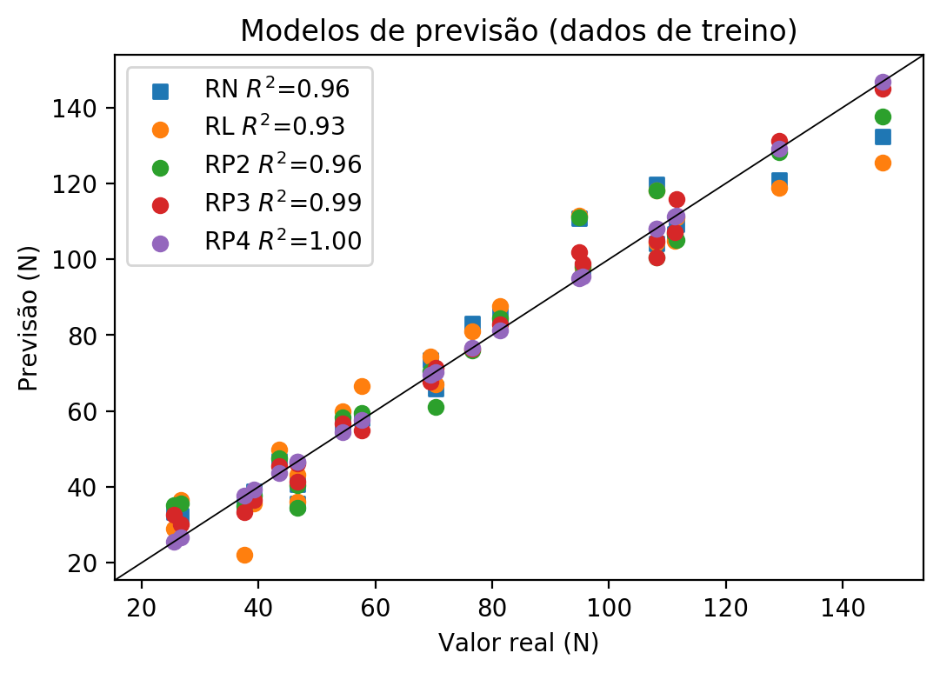

**Dados de teste**

|  |  |  |  |  |  |  |  |  |  |  |
| --- | --- | --- | --- | --- | --- | --- | --- | --- | --- | --- |
| Valor real | RN Previsto | RN Erro (%) | RL Previsto | RL Erro (%) | RP2 Previsto | RP2 Erro (%) | RP3 Previsto | RP3 Erro (%) | RP4 Previsto | RP4 Erro (%) |
| 37.12 | 33.01 | 11.07 | 29.37 | 20.88 | 32.04 | 13.69 | 52.4 | 41.16 | 50.97 | 37.31 |
| 113.01 | 110.14 | 2.54 | 112.06 | 0.84 | 121.51 | 7.52 | 120.17 | 6.34 | 149.27 | 32.09 |
| 76.1 | 74.3 | 2.37 | 80.48 | 5.76 | 70.5 | 7.36 | 58.46 | 23.18 | 73.19 | 3.82 |
| 84.21 | 68.76 | 18.35 | 73.28 | 12.98 | 63.21 | 24.94 | 61.93 | 26.46 | 59.47 | 29.38 |
| 41.06 | 40.57 | 1.19 | 42.73 | 4.07 | 39.39 | 4.07 | 38.63 | 5.92 | 58.99 | 43.67 |
| 65.15 | 67.2 | 3.15 | 73.8 | 13.28 | 64.5 | 1.0 | 63.14 | 3.09 | 65.08 | 0.11 |

**Dados de treino**

|  |  |  |  |  |  |  |  |  |  |  |
| --- | --- | --- | --- | --- | --- | --- | --- | --- | --- | --- |
| Valor real | RN Previsto | RN Erro (%) | RL Previsto | RL Erro (%) | RP2 Previsto | RP2 Erro (%) | RP3 Previsto | RP3 Erro (%) | RP4 Previsto | RP4 Erro (%) |
| 111.5 | 109.28 | 1.99 | 111.03 | 0.42 | 105.13 | 5.71 | 115.89 | 3.94 | 111.5 | 0.0 |
| 70.28 | 65.79 | 6.39 | 67.11 | 4.51 | 61.08 | 13.09 | 71.26 | 1.39 | 70.28 | 0.0 |
| 95.51 | 97.29 | 1.86 | 97.66 | 2.25 | 98.23 | 2.85 | 98.96 | 3.61 | 95.51 | 0.0 |
| 108.06 | 104.09 | 3.67 | 104.35 | 3.43 | 100.38 | 7.11 | 100.46 | 7.03 | 108.06 | 0.0 |
| 81.32 | 85.27 | 4.86 | 87.68 | 7.82 | 84.36 | 3.74 | 82.84 | 1.87 | 81.32 | 0.0 |
| 26.74 | 32.38 | 21.09 | 36.56 | 36.72 | 35.66 | 33.36 | 30.19 | 12.9 | 26.74 | 0.0 |
| 57.64 | 57.96 | 0.56 | 66.6 | 15.54 | 59.49 | 3.21 | 54.77 | 4.98 | 57.64 | 0.0 |
| 146.82 | 132.32 | 9.88 | 125.43 | 14.57 | 137.59 | 6.29 | 144.9 | 1.31 | 146.82 | 0.0 |
| 129.13 | 120.89 | 6.38 | 118.74 | 8.05 | 128.25 | 0.68 | 131.3 | 1.68 | 129.13 | 0.0 |
| 46.66 | 35.65 | 23.6 | 36.05 | 22.74 | 34.42 | 26.23 | 46.17 | 1.05 | 46.66 | 0.0 |
| 43.52 | 46.75 | 7.42 | 49.93 | 14.73 | 47.6 | 9.37 | 45.54 | 4.64 | 43.52 | 0.0 |
| 39.22 | 38.9 | 0.82 | 35.54 | 9.38 | 37.75 | 3.75 | 36.44 | 7.09 | 39.22 | 0.0 |
| 94.91 | 110.71 | 16.65 | 111.54 | 17.52 | 111.04 | 17.0 | 101.86 | 7.32 | 94.91 | 0.0 |
| 54.41 | 55.81 | 2.57 | 59.91 | 10.11 | 58.37 | 7.28 | 56.79 | 4.37 | 54.41 | 0.0 |
| 46.6 | 40.63 | 12.81 | 43.25 | 7.19 | 40.33 | 13.45 | 41.38 | 11.2 | 46.6 | 0.0 |
| 111.24 | 106.75 | 4.04 | 104.86 | 5.74 | 106.59 | 4.18 | 107.03 | 3.78 | 111.24 | 0.0 |
| 37.59 | 34.83 | 7.34 | 22.17 | 41.02 | 34.98 | 6.94 | 33.38 | 11.2 | 37.59 | 0.0 |
| 25.47 | 33.38 | 31.06 | 28.85 | 13.27 | 35.07 | 37.69 | 32.7 | 28.39 | 25.47 | 0.0 |
| 108.12 | 119.74 | 10.75 | 118.23 | 9.35 | 118.08 | 9.21 | 104.89 | 2.99 | 108.12 | 0.0 |
| 76.57 | 83.0 | 8.4 | 81.0 | 5.79 | 76.06 | 0.67 | 76.39 | 0.24 | 76.57 | 0.0 |
| 69.49 | 73.51 | 5.79 | 74.31 | 6.94 | 70.35 | 1.24 | 67.66 | 2.63 | 69.49 | 0.0 |